
www.globalsight.com

GlobalSight
Installation Guide

Version 7.1

3rd Party Components
for Windows
Open source initiative for
managing, translating &
delivering global content

Table of Contents
Table of Contents ii
Passwords for GlobalSight Components iii
Pre-requisites 1
Install the MySQL Database Server 5.1.25 2
Run the MySQL Server 5.1.25 Setup Wizard 2
Configure the Database 2
Creating the GlobalSight Database and User using MySQL Command Line 3
MySQL Quick Test: 4
Install the MySQL Client 5.1.25 6
Install JDK 1.6.0_07 8
Install JRE 1.6.0_07 for Client 9
Install OpenLDAP 2.2.29 10

Passwords for GlobalSight Components
When installing GlobalSight components, you will be defining passwords for MySQL, OpenLDAP. Therefore, for simplicity choose one cross-component password now that you will use for all these components.
Choose an 8-character password that is the combination of the company name and an integer.
For reference, the following is a list of usernames and passwords for all the GlobalSight components. The cross-component GlobalSight password is represented by <password> in the table below.
Component | Username | Password | Description
MySQL | root | root | Root-user for MySQL. “root” is the default password. The password for your MySQL installation may be different. You’ll need this for creating the GlobalSight MySQL resources.
MySQL | globalsight | <password> | The user that owns all the GlobalSight tables.
OpenLDAP connection | ldap_connection | <password> | The username and password used by GlobalSight to connect to OpenLDAP for user and role information.

Pre-requisites
Download the GlobalSight Software Package for Windows from www.globalsight.com and unzip the package.
After unzip, you should have the following directories:
- 3rd_party_software
- Aligner
- Converters
- DesktopIcon
- Documentation
- GlobalSight

Install the MySQL Database Server 5.1.25
These instructions are for MySQL Database Server Version 5.1.25.
If you plan to install MySQL Database Server and GlobalSight application on separate servers, you will need to install MySQL Client on the server where you will be installing the GloblalSight application. Please see Install the MySQL Client 5.1.25 section in this document for instructions.

Run the MySQL Server 5.1.25 Setup Wizard
- Double-click on Setup.exe to launch the MySQL Server 5.1.25 Setup Wizard.
- Wait until the welcome screen shows. Then click Next.
- On the Setup Type screen, choose Custom. Click Next.
- On the Custom Setup screen, click the button Change… and adjust the install directory then click Next.
- On the Ready to Install the Program screen. Click Install.
- Wait until the installation complete. After that there may be screens of introduction of MySQL Enterprise. Just click Next.
- On the Wizard Completed screen. Accept Configure the MySQL Server now. Click Finish. And do configurations written in the next section.

Configure the Database
- When the Welcome to the MySQL Server Instance Configuration Wizard 1.0.12.0 screen opens, on the Welcome screen, click Next.
- On the Select a configuration type screen, choose Detailed Configuration. Click Next.
- On the Select a server type screen, choose Server Machine. Click Next.
- On the Select the database usage screen, choose Transactional Database only. Click Next.
- On the Select the drive for the InnoDB datafile screen, accept the default setting Installation Path. Click Next.
- On the Set the approximate number of concurrent connections to the server screen, choose Online Transaction Processing (OLTP) or Manual Setting -> set the concurrent connections to 500. Click Next.
- On the set the networking options screen, select Enable TCP/IP Networking and let the Port Number to 3306 and choose Add firewall exception for this port and select Enable Strict Mode. Click Next.
- On the Select the default character set screen, choose Best Support for Multilingualism. Click Next.
- On the Set the Windows Options screen, select Install as Windows Service and set the Service Name ( e.g. “MySQLGlobalSight” ), select Launch the MySQL Server automatically, and select Include Bin Directory in Windows PATH. Click Next.
- On the Set the Security Options screen, select Modify Security Settings and set the password to “root” for the MySQL root user and confirm the password, DO NOT check Enable root access from remote machines. Click Next.
- After the configuration completed. Click Finish to close the wizard.
- Edit MySQL_HOME\my.ini. Change the value of option “max_allowed_packet” to 16M. If option “max_allowed_packet” does not exist, add max_allowed_packet = 16M to the bottom of mysqld section.
- Restart MySQL service (in Administrator Tools/Services).

Creating the GlobalSight Database and User using MySQL Command Line
- Login to mysql as root
Type: mysql -uroot –p<mysql_root_password> -h<MySQL_Host_name_or_ip_Addr>
Example: C:\>mysql –uroot –proot –hlocalhost

Note: Assuming that MySQL Database server has been successfully installed and you will be executing mysql commands on the same host. Also, assume that the MySQL root user's password is set to 'root'.
- Create GlobalSight database
Type: create database <GlobalSight Database Name>;
Example: mysql> create database globalsight;
- Create GlobalSight database user name
Type: create user '<User Name>'@'%' identified by '<Password>';
Example: mysql> create user 'globalsight'@'%' identified by 'password';
- Grant all privileges on GlobalSight database (created in step 2 above) to the user (created in step 3 above)
Type: grant all on <GlobalSight Database Name>.* to '<User Name>'@'%';
Example: mysql> grant all on globalsight.* to 'globalsight'@'%';
- Commit
Type: commit;
Example: mysql> commit;

MySQL Setup Quick Test:
- Login to MySQL with the user created earlier (will use Mysql user 'globalsight' and password 'password' for this example)
Type: mysql –uglobalsight –ppassword –hlocalhost
- Once successful login, conect to MySQL database created earlier (will use database name 'globalsight' for this example)
Type: connect globalsight;
- Check status
Type: status
Note: You should see status showing 'Current database:' and 'Current user:' match information entered above.
You will use the MySQL username, password and database name later in the GlobalSight setup.
- Test completed, exit MySQL.
Type: exit

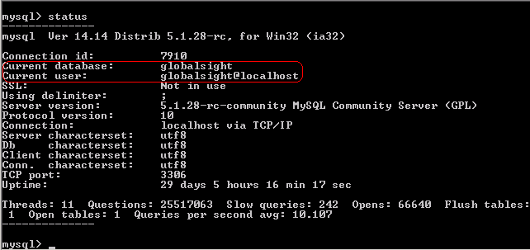

Install the MySQL Client 5.1.25
If you plan to install MySQL Database Server and GlobalSight application on separate servers, you will need to install MySQL Client on the server where you will be installing the GloblalSight application.
- Double-click on Setup.exe to launch the MySQL 5.1.25 Setup Wizard.
- Wait until the welcome screen shows. Then click Next.
- On the Setup Type screen, choose Custom. Click Next.
- On the Custom Setup screen
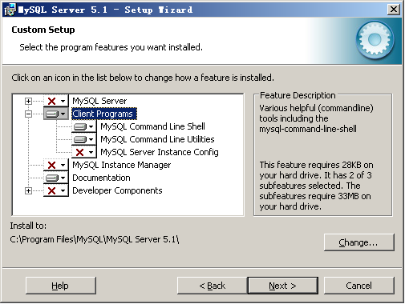
  - Click the images to de-select all features first and select “Client Programs -> MySQL Command Line Shell” & “Client Programs -> MySQL Command Line Utilities” to install
  - Select “Documentation” to install if you like.
  - Click the button Change… and adjust the install directory
  - Click Next.
- On the Ready to Install the Program screen. Click Install.
- Wait until the installation complete. After that there may be screens of introduction of MySQL Enterprise. Just click Next.
- On the Wizard Completed screen. Click Finish to the installation.
- Set Environment Variables for System variable Path:
Go to My Computer -> Properties -> Advanced -> Environment Variables.
Add <MySQL_home>\bin (example: C:\Program Files\MySQL\MySQL Server 5.1\bin) to the end of Path variable_value

Install JDK 1.6.0_07
- Uninstall any previously installed JDK.
- Download the JDK 1.6.0_07. You can also find the setup file in the GlobalSight Software Package.
- Install JDK 1.6.0_07 by double clicking on jdk-6u7-windows-i586-p.exe.
- License Agreement Screen.
  - Select “I accept the terms in the license agreement.”
  - Click next.
- On the Custom Setup Screen.
  - Choose the installation directory.
e.g.: C:\Program Files\Java\jdk1.6.0_07
  - Click next.
- On the JRE installation screen.
  - Click next to install.
- On the InstallShield Complete screen, click on Finish. This will require a restart of the server.
- When done, set the following System (not User) environment variables from My Computer -> Properties -> Advanced -> Environment Variables:
  - JAVA_HOME=<java_home> (for example: C:\Program Files\Java\jdk1.6.0_07)
  - Add %JAVA_HOME%\bin to the front of PATH variable.

Install JRE 1.6.0_07 for Client
To access GlobalSight application, the client machine should have JRE version 1.5 or above. Here are the instructions to install JRE 1.6 update 07.
- Uninstall any previously installed JRE.
- Download the JRE 1.6.0_07. You can also find the setup file in the GlobalSight Software Package.
- Install JRE 1.6.0_07 by double clicking on jre-6u7-windows-i586-p.exe.
- License Agreement Screen.
  - Select “I accept the terms in the license agreement.”
  - Click next.
- Select the install directory if you like and click next all the way.
- On the InstallShield Complete screen, click on Finish.

Install OpenLDAP 2.2.29
Install OpenLDAP on the server where GlobalSight application will be installaed. For a clean install, please remove the OpenLDAP installation directory (if it exists from a prior GlobalSight installation).
- Download OpenLDAP 2.2.29. You can also find the setup file in the GlobalSight Software Package.
- Double click on openldap-2.2.29-db-4.3.29-openssl-0.9.8a-win32_Setup.exe
- Click Next.
- Accept the license agreement. Click Next.
- Enter or browse to the installation Directory (Make sure the path does NOT contain white space or non-ASCII characters). Click Next.
- Select Full installation. Click Next.
- Choose how to generate OpenLDAP menu in the Start Menu. Click Next.
- Check “automatically start OpenLDAP NT service(s) after reboot” and “Create a desktop icon” (default). Click Next.
- Review installation components on Ready to Install screen. Click Install to install OpenLDAP.
- Click Finish to finish the installation.
- Go to Windows Administrative Tools/Services to start the OpenLDAP Directory Service.

